Fun night presenting...
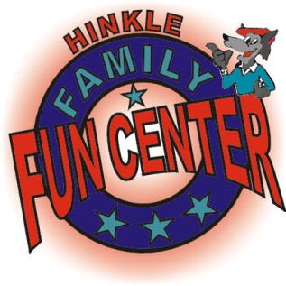
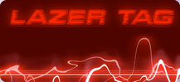
Lazer Tag at Hinkle!!!
October 5, 2010 at 6:30 PM
12931 Indian School Rd NE, 87112
As far as I know, never done before by Troop 1!!! Don't miss it!!!
-What are we going to do?
We are going to participate in two lazer tag missions!! We will also allot about one half hour, give or take 15 minutes, (probably take instead of give) to play arcade games in Nickel City.
-Timing and placement
Meet at the hinkle family fun center lazer tag building at 6:30 pm Tuesday (the 5th). We should end around 8:00 pm. The lazer tag building is the one containing Nickel City and is on the west portion of the complex.
-Price
Bring about $20 because on the website it says two lazer tag missions costs $11.95 and a Nickel City Armband is $2.50 and a fun card is $1, and the rest can be used on credits to play games. Nickel city credits cost... well my best guess is a nickel. Drinks and food are on you! If you want these, bring extra $$$! Plan accordingly!
-other questions
Ask Kyle Buchmiller!!
Hope to see you there!!!
bhbsatroop1@comcast.net

