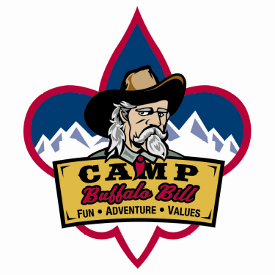
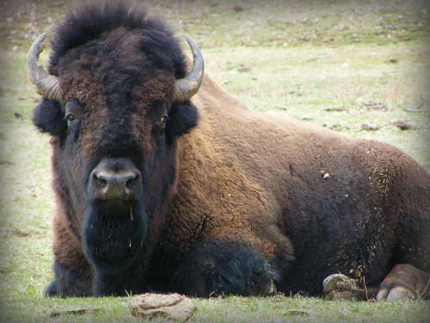
Summer Camp 2011
Fri, July 15 – Sun, July 24

Location: Camp Buffalo Bill (7 miles E of Yellowstone East Entrance or 43 miles West of Cody, WY)
http://www.wyoscouts.org/campbuffalobill.htm

Itinerary: Drive 07/15 - 07/16 (Camp En Route)
Yellowstone/Grand Tetons 07/17 (Camp @ BB)
Summer Camp 07/18 – 07/19
Yellowstone/Grand Tetons 07/20
Summer Camp 07/21 – 07/22
Return 07/23 – 07/24 (Camp En Route)

Fees: *Scout Base Fee $425
*Adult Base Fee $300
**Fly-Fishing Fee $50
***High Adventure (Backpacking, Rafting, Climbing) $75

*Meals outside of camp NOT included. Recommend budgeting $10 x 13 = $130 additional.
**Optional activity
***Optional activity and must be 14 years old or 13 years old with 8th grade completed.

Schedule: October 26: $100 + Fly-Fishing and/or High Adventure Fees (Scouts & Adults)
January 25: $100 (Scouts)
February 22: $100 (Scouts & Adults)
March 29: $125 (Scouts), $100 (Adults)

Other: Availability based upon # of drivers and camp site space on a first-come, first-serve basis
Additional late fees apply if registration occurs after 03/01
Deposits/Fees are non-refundable unless a replacement is located
Recommend $25 - $50 spending money for MB material costs, snacks, add’l incidentals
Complete, current Medical Form due July 05
Family Camping Available at Camp Buffalo Bill @ ~$60 per person, per day
Fuel surcharge could be added if avg price per gallon is more than $3 per gallon
If trip is under budget by $25+ per individual, balance will be returned.

See Brian Green 856.3684/brian_green_abq@yahoo.com to sign-up or for further details.

