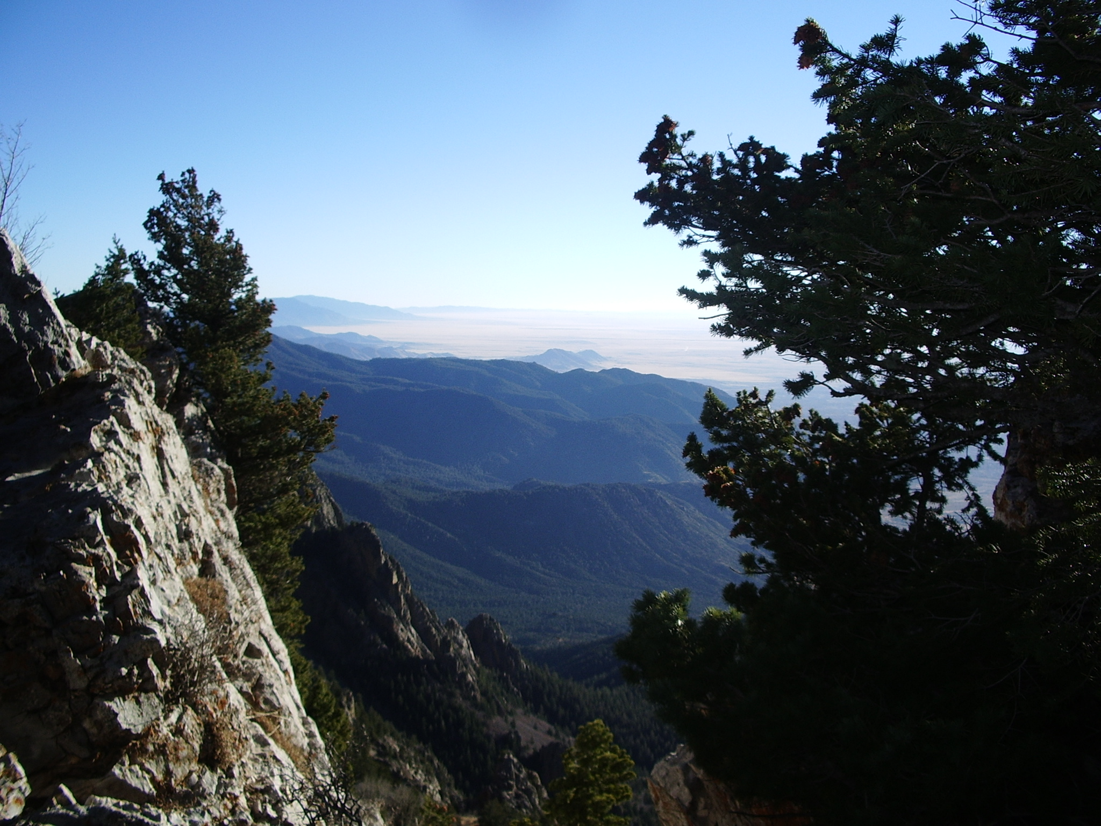 | Troop 1  Sandia Mountains Hike  Saturday  March 20th, 2010  8:00 AM to 1:00 PM | 
WHO: Scouts, Parents and Old Goats of Troop One!!
WHAT: Hike in the Sandia Mountains, moderate difficulty - 2.5 miles each way, with 1800’ elevation gain
WHEN: Saturday, March 20th, 2010 (The first day of SPRING!)
MEET: 7:50 AM at Sandia Presbyterian Church
DEPART: 8:00 AM
RETURN: 1:00 PM at Sandia Presbyterian Church
WHERE: Hawk Watch Trail - Three Guns Springs Trailhead near Carnuel, a 25 minute drive from the church
TIMES: Meet and depart from the church Saturday, March 20th at 8:00AM -- Return to the church around 1:00PM
BRING: BE PREPARED!! Bring a day pack, personal first aid kit, water bottle, and trail snacks. OPTIONAL: food for lunch, binoculars, camera. No other electronics. Prepare for cool windy weather.
------------------------ CUT HERE  ----------- CUT HERE  ---------- CUT HERE  ---------- CUT HERE  ---------------------- CUT HERE  -------------------

 REGISTER TO PARTICIPATE IN THE HIKE - PLEASE PRINT 
Put this registration form in Mr. Karasz’s hand …THANK YOU!!!

Scout’s Name_________________________________ Patrol _________________

Names of Adult(s) Going: ______________________________________________
WE CAN DRIVE…
What vehicle will you be driving? _________________________________________________
Year Make Model #Seatbelts

