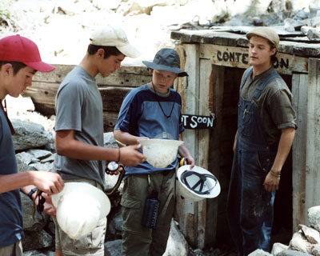
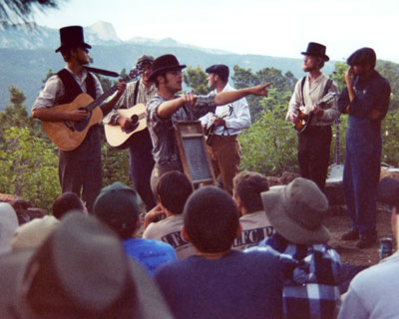
Troop 1 Philmont 2012
Backpacking Expedition

Sat, June 16 - Thu, June 28
2012 (NOT 2011)

This is a chance to backpack into Philmont Scout Ranch, south of Cimarron, New Mexico for twelve days. Each day you will backpack to a new campsite, most of which offer pole-climbing, gold panning, tomahawk throwing, or other equally challenging and exciting activities. You will be carrying a backpack with your personal equipment and a portion of the crew equipment that may total somewhere between 35 and 60 pounds (based on your body weight). You will climb mountains, ford streams, build shelters, and explore a beautiful back country area that is reserved for members of the Boy Scouts of America. You will eat well, being resupplied along the way as necessary (so you don’t have to carry 12 days’ worth of food from the start). You will be challenged and encouraged to “make it in the great outdoors”.
More details will be given as we get closer to the departure date (preparatory backpacking trips, packing lists, medical reminders, and so on). For now, join in by simply making the required payments (listed on the back of this form). Fund raising for those planning to participate will hopefully begin in late summer of 2011 (more details will follow from the Troop Committee as it becomes available).

Location: Philmont Scout Ranch (http://www.philmontscoutranch.org)

Itinerary: Saturday, 16 June, 2012 - Drive to Philmont in the morning
Thursday, 28 June, 2012 - Return to Albuquerque in the afternoon
NOTE: This is almost two full weeks, especially important to adults.

Fees: $765 per participant (breakdown below) (payment due dates on back)
$740 for Philmont Expedition cost
$25 for transportation costs from Albuquerque to/from Philmont
Please bring an additional $20 each for snacks/incidentals/meals on the trip

Payment Due Dates:
15 February, 2011: $25 Down-payment to hold reservation
7 June, 2011: $100
2 August, 2011: $100
6 September, 2011: $100
4 October, 2011: $100
1 November, 2011: $100
9 January, 2012: $100
7 February, 2012: $100
6 March, 2012: $40 (final payment)

Other:
  - All participants must be registered Boy Scouts or adult leaders and must meet the Philmont Weight Limits for Backpacking and Hiking. These limitations apply to adults and Boy Scouts, who may weigh either too much or too little to participate.
  - All Boy Scouts must be 14 years old, or must be 13 years old and have finished the eighth grade, by 15 June 2012.
  - Reservations for Boy Scouts is on a first-come, first-served basis based on payments. A maximum of ten Boy Scouts can participate (a minimum of five are required).
  - Availability for adult leaders is on a first-come, first-served basis based on payments and qualifications (adults with current Wilderness First Aid (WFA) certification in June 2012 will be given preference). A minimum of two adult leaders are required (one with WFA), and a maximum of five adults are allowed.
  - A maximum of twelve participants are allowed, with preference given to Boy Scouts over adults up to the maximum of ten Boy Scouts.
  - Payments are non-refundable unless a replacement Scout or adult leader is found. If an adult leader is asked to give up his/her reservation so that a Boy Scout can participate, the adult leader’s fees will be refunded once the Boy Scout has paid.
  - Scouts and adults must provide a complete, current Medical Form (including physical) to the Troop no later than 5 June, 2012.
  - All participants are required to complete at least two of the preparatory backpacking trips that will be offered during early 2012 (exact dates and locations are TBD but will be announced in early 2012; more than two trips will be offered). Non-Troop 1 backpacking trips during early 2012 may be acceptable alternatives based on the location, duration, and time frame; see Mr. Hanson, Mr. Karasz, or Mr. Green for details.

Contact Brian Green at 856-3684 or brian_green_abq@yahoo.com to sign-up or for further details.

